Chapter 4

Factoring

Section 4.1: Greatest Common Factor and Factoring by

Grouping

- GCF and Grouping

GCF and Grouping

Finding the Greatest Common Factor:
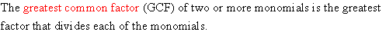

Example:

Solution:
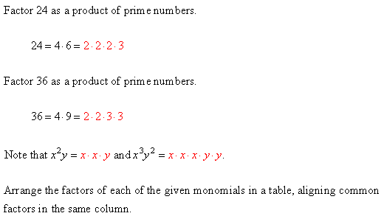

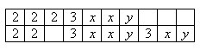

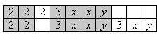

Factoring Out the Greatest Common Factor:
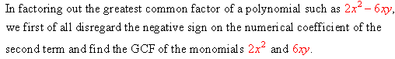
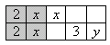

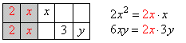

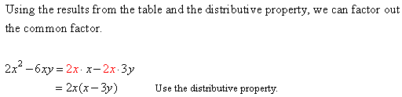
Example:

Solution:
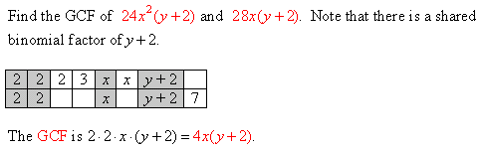

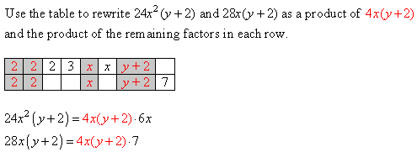

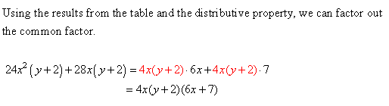

Factoring by Grouping:
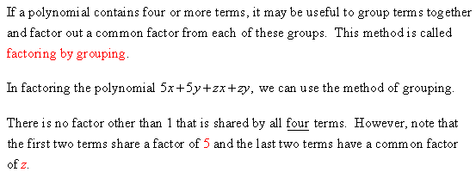

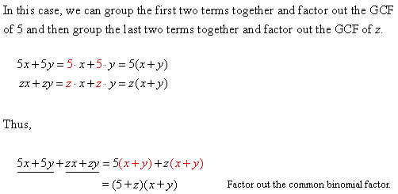

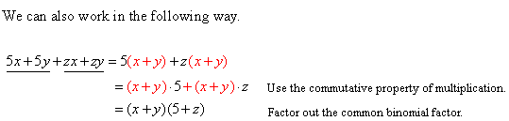

Additional Example 1:

Solution:
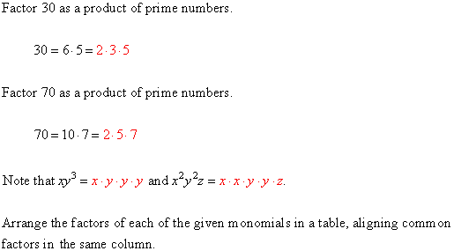

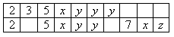

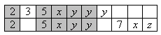

Additional Example 2:

Solution:
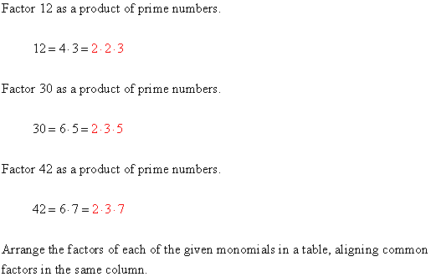

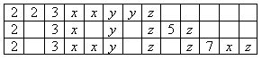

The GCF is the product of the factors that are shared by all three monomials.
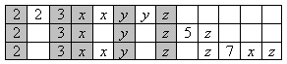

Additional Example 3:
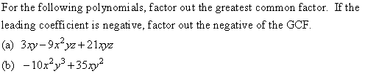

Solution:
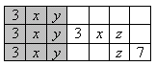

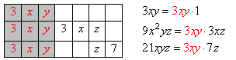

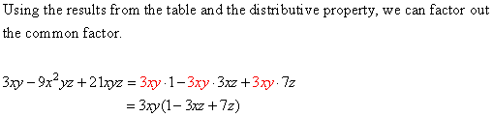

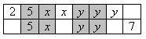

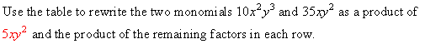
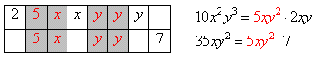

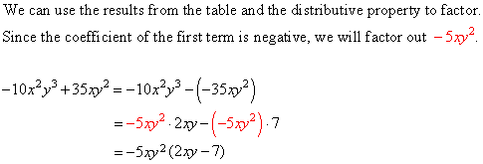

Additional Example 4:

Solution:
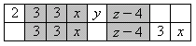

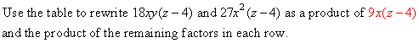
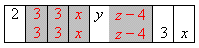

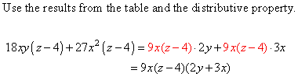

Additional Example 5:

Solution:
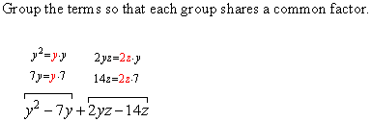

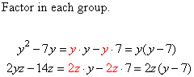

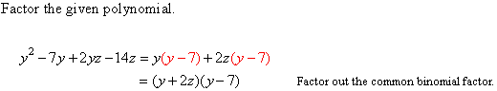

Find the GCF (Greatest Common Factor) of the following monomials.

Find the GCF of the terms of the polynomial and factor it out. If the leading coefficient is negative, then factor out the negative of the GCF.

Factor the following expressions.
- (a)
(b)
- (a)
(b)
- (a)
(b)
- (a)
(b)

Factor by grouping.

Factor by grouping. (Hint: Use groups of three.)

Each of the following expressions contains like terms. Do not combine the like terms; instead, simply factor by grouping. (This method will be helpful in the next section when factoring trinomials.)

Section 4.2: Factoring Special Binomials and Trinomials

- Special Factor Patterns

Special Factor Patterns

Factoring the Difference of Two Squares:
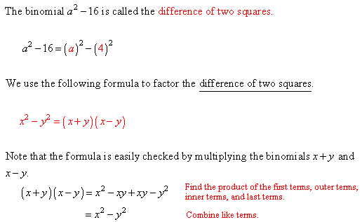

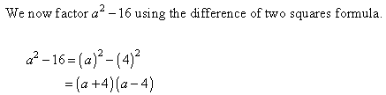

Example:

Solution:
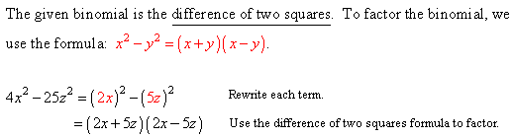

Note:
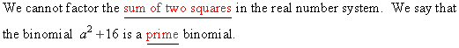

Factoring the Difference of Two Cubes:
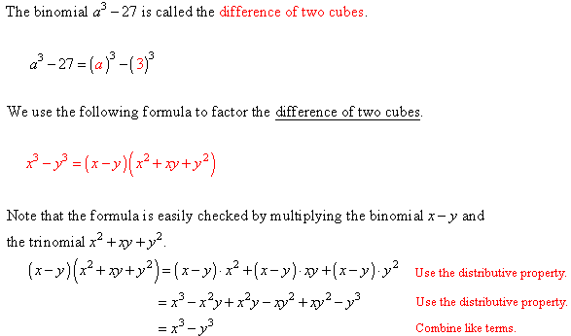

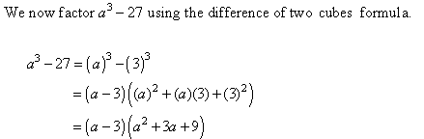

Example:
Solution:
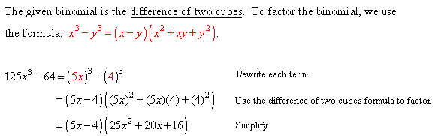

Factoring the Sum of Two Cubes:
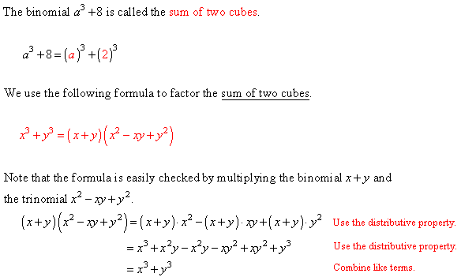

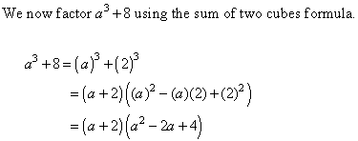

Example:
Solution:
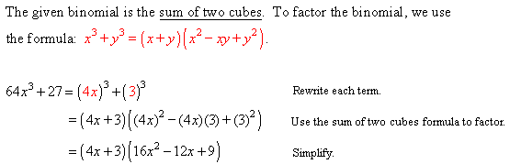

Factoring Perfect Square Trinomials:
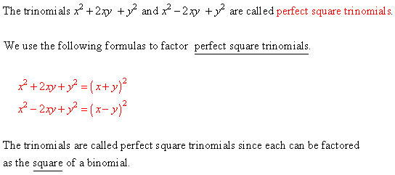

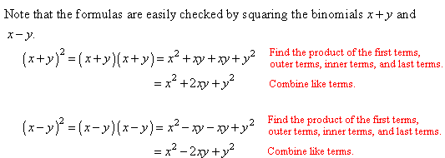

Example:

Solution:
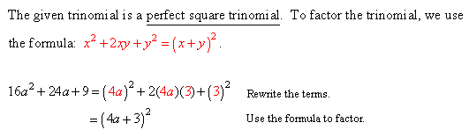

Additional Example 1:
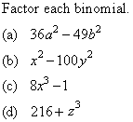

Solution:
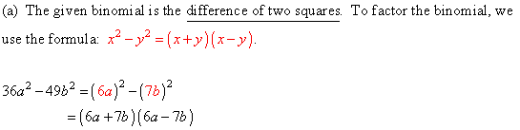

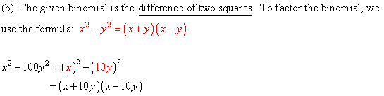

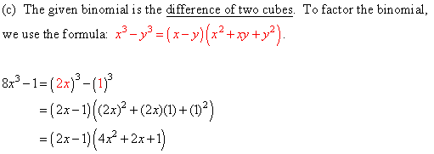
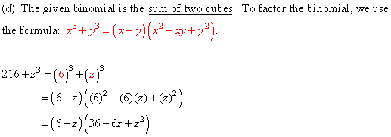

Additional Example 2:
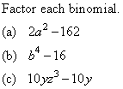

Solution:
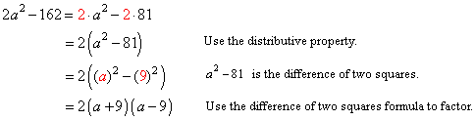

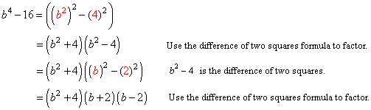

(c) The monomials and share a common factor of The first step in
factoring the given binomial to factor out the GCF of .
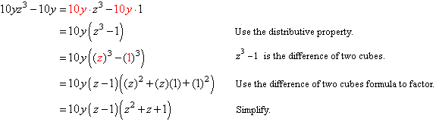

Additional Example 3:
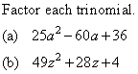

Solution:
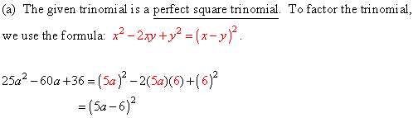

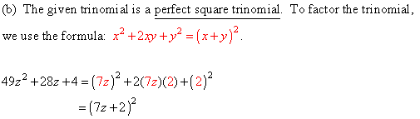

Additional Example 4:
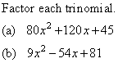
Solution:
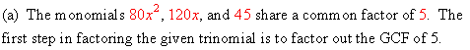
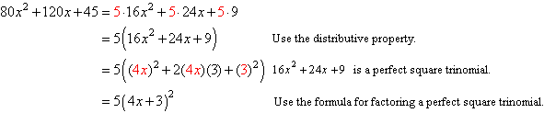

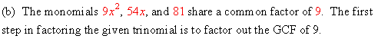
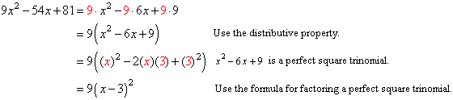

Multiply the following.
- (a)
(b)
(c)

- (a)
(b)
(c)

Answer True or False.

Factor the following polynomials. If the polynomial can not be factored any further within the real number system, then write the original polynomial as your answer.
- (a)
(b)
(c)
(d)

- (a)
(b)
(c)
(d)

When the remainder is zero, the dividend can be written as a product of two factors (the divisor and the quotient), as shown below.

, so .

, so

In the following examples, use either long division or synthetic division to find the quotient, and then write the dividend as a product of two factors.

Factor the following polynomials.

Section 4.3: Factoring Polynomials

- Techniques for Factoring Trinomials

Techniques for Factoring Trinomials

Factorability Test for Trinomials:
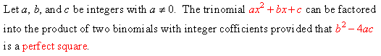

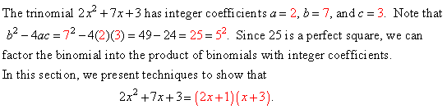

Example:

Solution:
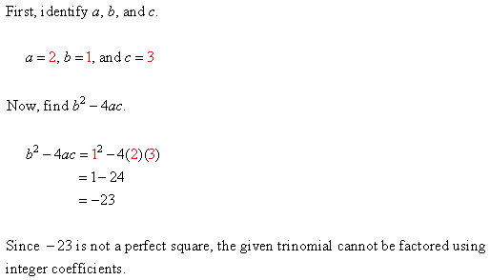

Factoring Trinomials with Leading Coefficient 1:
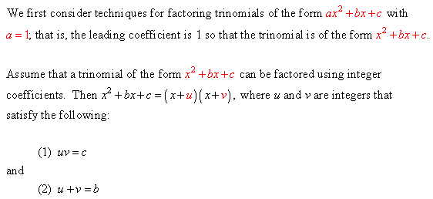

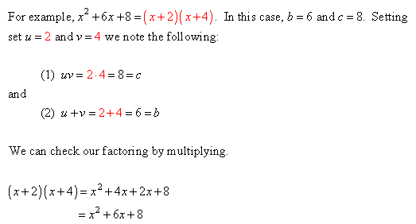

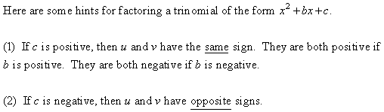

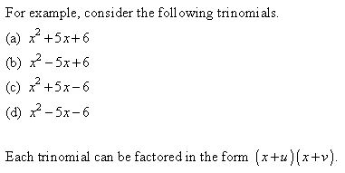
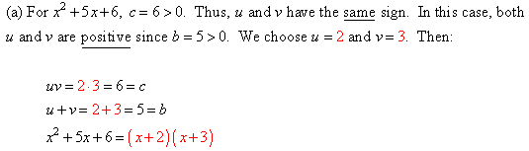

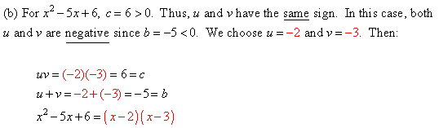

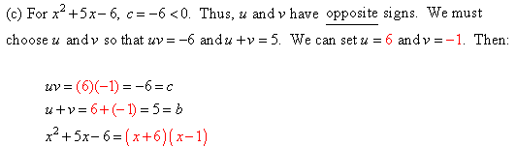

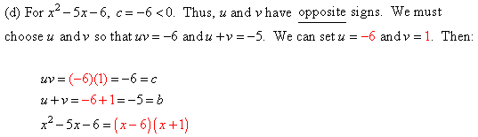

Example:
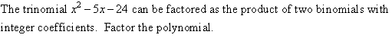

Solution:
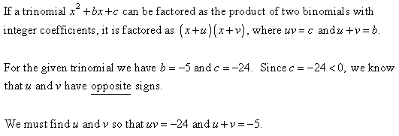

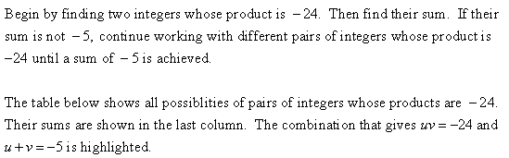

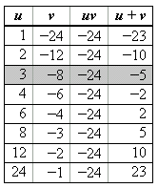

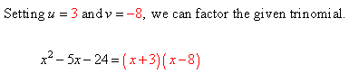

Factoring Trinomials with Leading Coefficient Different from 1:
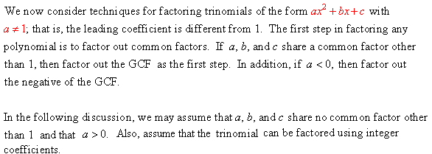

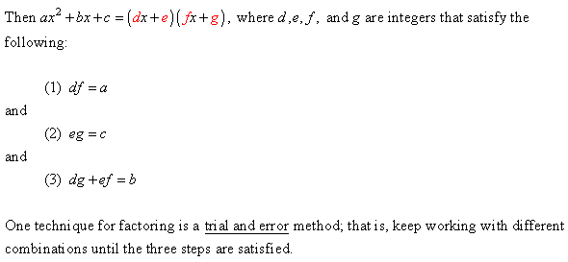

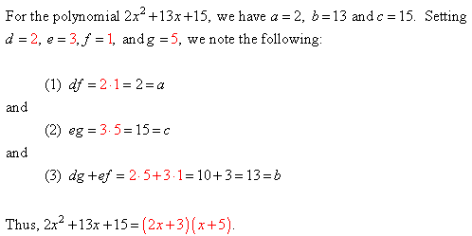

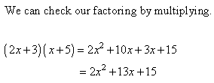

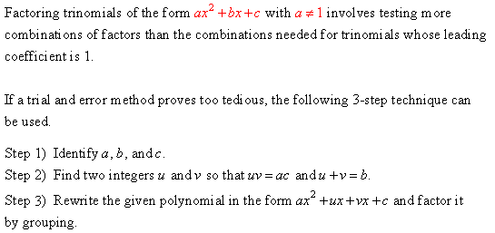

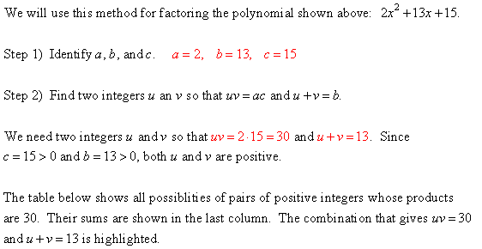

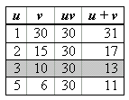

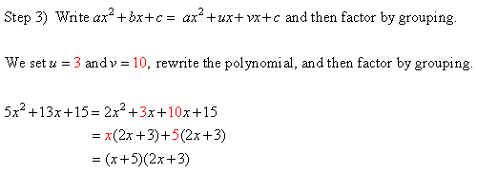

Example:

Solution:
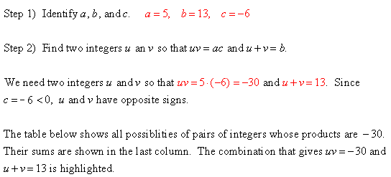

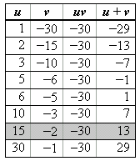

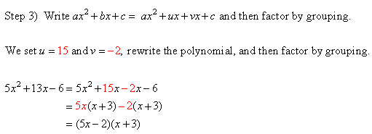

Additional Example 1:
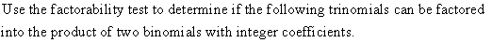
(a)
(b)

Solution:
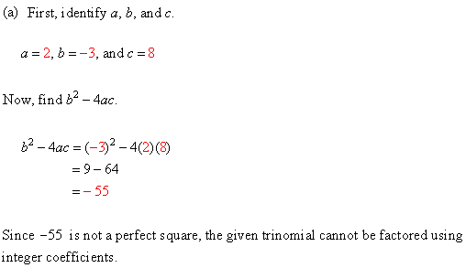

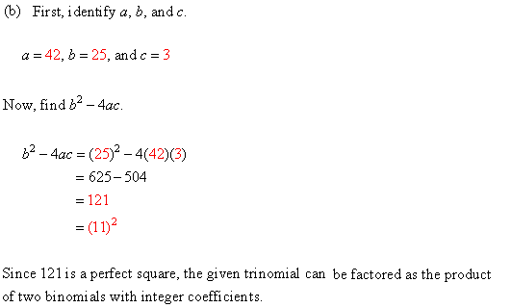

Additional Example 2:

Solution:
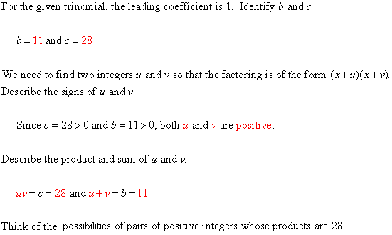

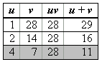

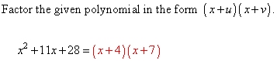

Additional Example 3:

Solution:
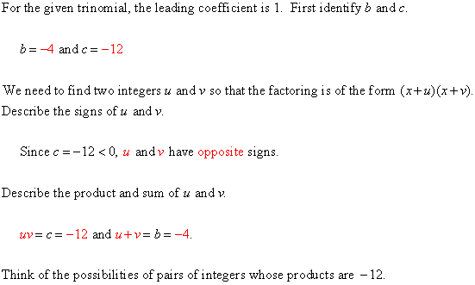

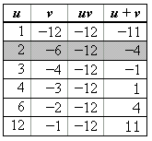

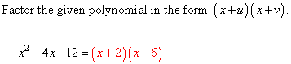

Additional Example 4:
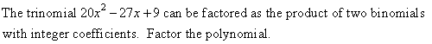

Solution:
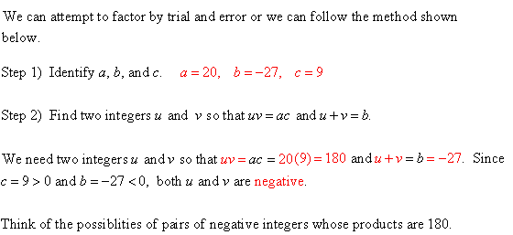

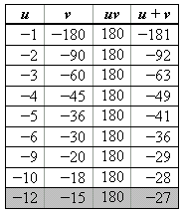

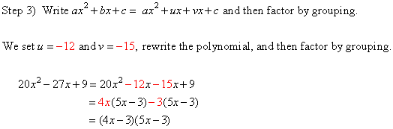

Additional Example 5:
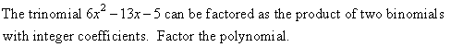

Solution:
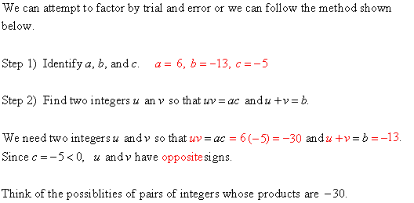

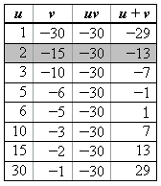

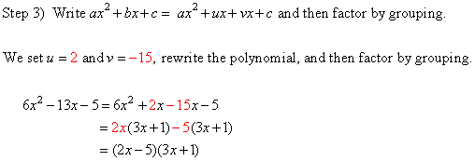

At times, it can be difficult to tell whether or not a quadratic of the form can be factored into the form , where a, b, c, d, e, f, and g are integers. If is a perfect square, then the quadratic can be factored in the above manner.

For each of the following problems,
(a) Compute .
(b) Use the information from part (a) to determine whether or not the quadratic can be written as factors with integer coefficients. (Do not factor; simply answer Yes or No.)

Factor the following polynomials. If the polynomial can not be rewritten as factors with integer coefficients, then write the original polynomial as your answer.

Factor the following. Remember to first factor out the Greatest Common Factor (GCF) of the terms of the polynomial, and to factor out a negative if the leading coefficient is negative.

Factor the following polynomials. (Hint: Factor first by grouping, and then continue to factor if possible.)

Section 4.4: Using Factoring to Solve Equations

- Solving Quadratic Equations by Factoring
- Solving Other Polynomials Equations by Factoring

Solving Quadratic Equations by Factoring

Zero-Product Property:
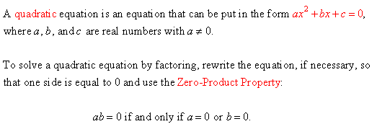

Example:

Solution:
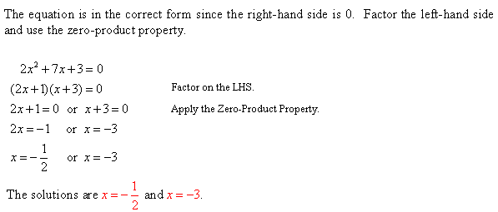

Example:
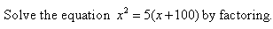

Solution:
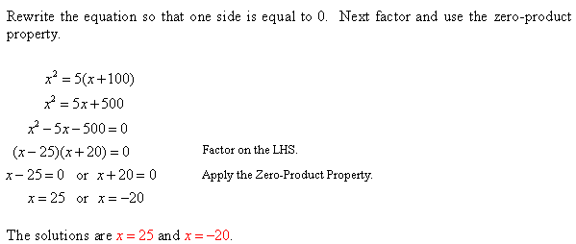

The x-Intercepts of the Graph of a Quadratic Function:
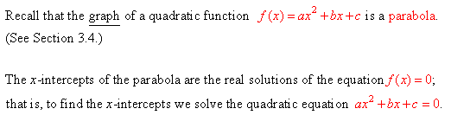

Example:

Solution:
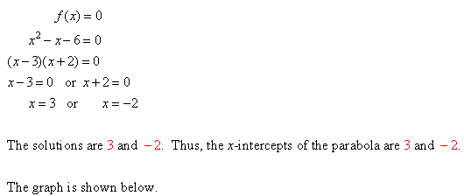

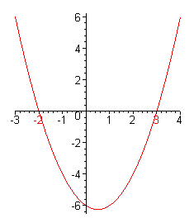

Additional Example 1:

Solution:
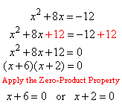

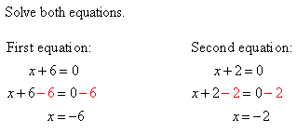

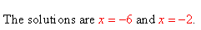

Additional Example 2:
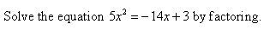
Solution:
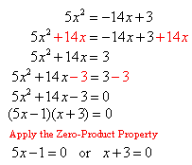

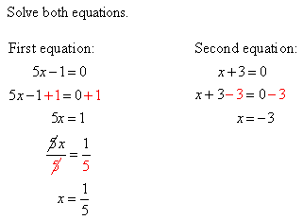

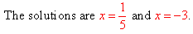

Additional Example 3:
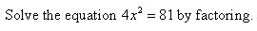

Solution:
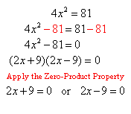

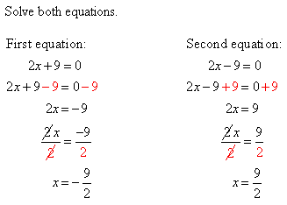

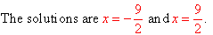

Additional Example 4:
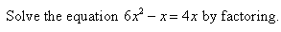

Solution:
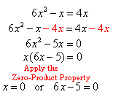

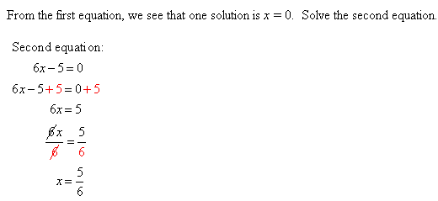

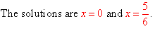
Additional Example 5:

Solution:
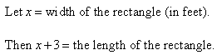

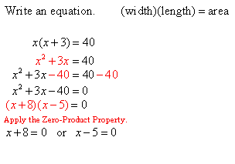

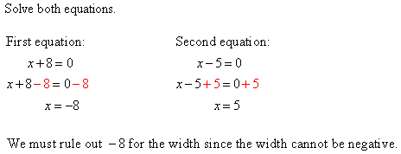

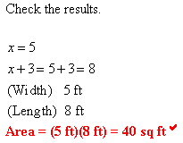

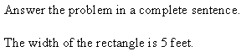

Additional Example 6:
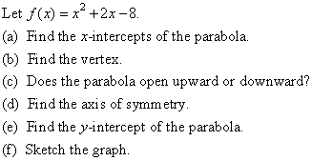

Solution:
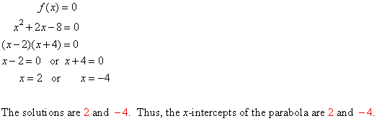

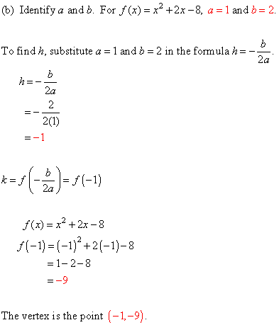

(c) Since , the parabola opens upward.

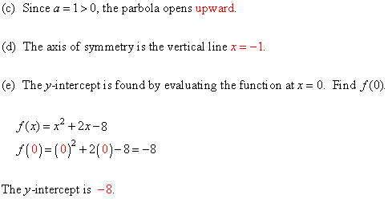

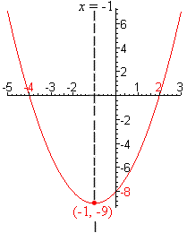

Solving Other Polynomial Equations by Factoring

Solving Polynomial Equations by Factoring:
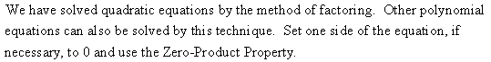

Example:
Solution:
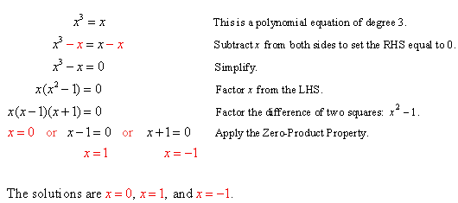

Example:

Solution:
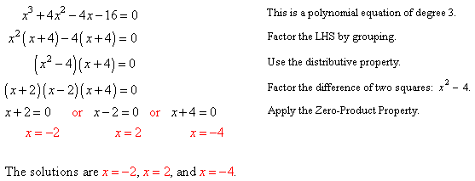

The x-Intercepts of the Graph of a Polynomial Function:
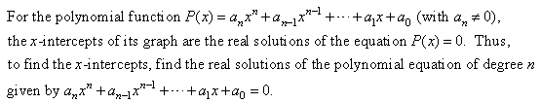

Example:

Solution:
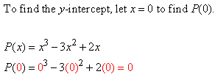

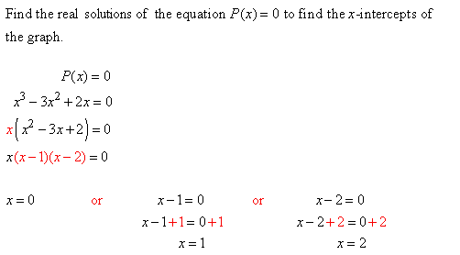

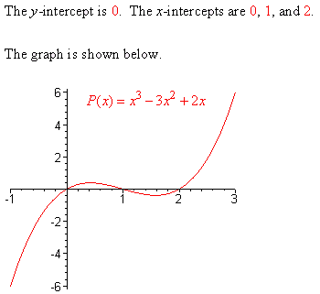

Additional Example 1:

Solution:
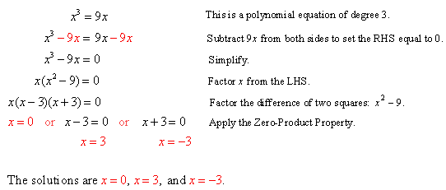

Additional Example 2:

Solution:
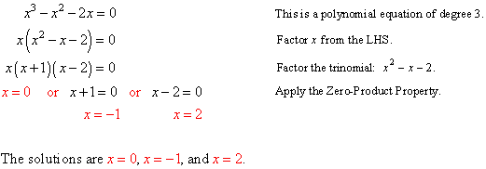

Additional Example 3:

Solution:
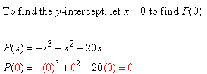
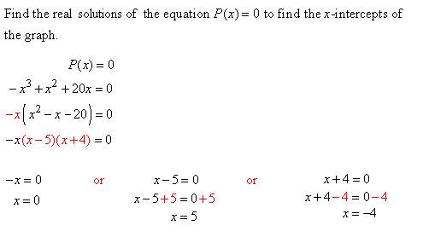

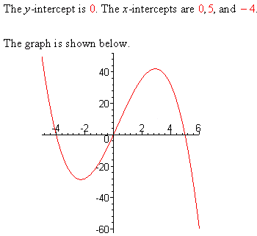

Solve the following equations by factoring.

- $$x^{2}−\text{10}x+\text{21}=0$$
- $x^{2}+\text{13}x+\text{40}=0$
- $$x^{2}+8x+\text{12}=0$$
- $$x^{2}−6x−\text{40}=0$$
- $$x(x−2)=\text{35}$$
- $$x(x+8)=\text{20}$$
- $$x^{2}+\text{14}x=\text{72}$$
- $$x^{2}−\text{60}=\text{11}x$$
- $2x^{2}−7x−\text{15}=0$
- $3x^{2}−7x+4=0$
- $$6x^{2}+\text{17}x=−\text{12}$$
- $$\text{10}x^{2}−7x=6$$
- $$3x^{2}−5x=−2$$
- $$8x^{2}−6x−5=0$$
- $$x^{2}−\text{25}=0$$
- $$x^{2}−\text{49}=0$$
- $$4x^{2}−9=0$$
- $$\text{36}x^{2}−\text{25}=0$$

Solve the following equations by factoring. To simplify the process, remember to first factor out the Greatest Common Factor (GCF) and to factor out a negative if the leading coefficient is negative.

- $$x^{2}−8x=0$$
- $$x^{2}+\text{10}x=0$$
- $$−3x^{2}+\text{21}x=0$$
- $$5x^{2}−\text{30}x=0$$
- $$3x^{2}−\text{12}=0$$
- $$−7x^{2}+7=0$$
- $$−5x^{2}−\text{15}x+\text{90}=0$$
- $$−4x^{2}+\text{20}x+\text{24}=0$$
- $$\text{80}x^{2}+\text{230}x−\text{30}=0$$
- $$\text{12}x^{2}−\text{75}x+\text{18}=0$$

Each of the quadratic functions below is written in the form . The graph of a quadratic function is a parabola with vertex, where and .
- Find the x-intercept(s) of the parabola by setting and solving for x.
- Write the coordinates of the x-intercept(s) found in part (a).
- Find the y-intercept of the parabola and write its coordinates.
- Give the coordinates of the vertex (h, k) of the parabola, using the formulas and .
- Does the parabola open upward (with the vertex being the lowest point on the graph) or downward (with the vertex being the highest point on the graph)?
- Find the axis of symmetry. (Be sure to write your answer as an equation of a line.)
- Draw a graph of the parabola that includes the features from parts (b) through (e).

Find the x-intercept(s) of the following.

For each of the following problems:
(a) Model the situation by writing appropriate equation(s).
(b) Solve the equation(s) and then answer the question posed in the problem.

- The length of a rectangular frame is 5 cm longer than its width. If the area of the frame is 36 cm², find the length and width of the frame.

- The width of a rectangular garden is 8 m shorter than its length. If the area of the field is 180 m², find the length and the width of the garden

- The height of a triangle is 3 cm shorter than its base. If the area of the triangle is 90 cm², find the base and height of the triangle.

- Find x if the area of the figure below is 26cm². (Note that the figure may not be drawn to scale.)

x cm
x cm
3 cm
8 cm

