Undergraduate Colloquium
November 7, PGH 646, 4:15pm
Simple models for complex physical phenomena
--- Professor Stephen Shipman ---
Louisiana State University

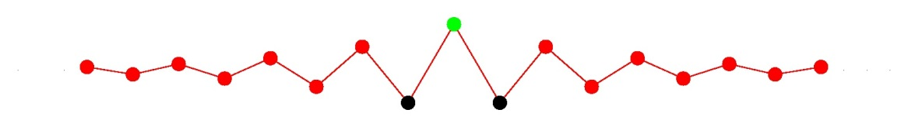
Abstract
Real physical systems are usually too complicated to describe mathematically in detail. What we try to do instead is to isolate essential features of a system and devise an analytically tractable model system that exhibits those features. I will illustrate this philosophy with a simple chain of beads connected by springs that nicely exhibits the phenomena of wave propagation and inhibition in crystalline materials as well as confinement of energy at defects.
Before the talk: recognition and awards of the UH students who scored in the 2012 Putnam Undergraduate Mathematical Competition
www.math.uh.edu/colloquium/undergraduate

