Math 1311

**Homework 2 (Section 1.3 – Section 1.4)**

Record your answers to all the problems in the EMCF titled “**Homework 2**.”

Use the following graph of a function $f=f(x)$ for Exercises 1-6.

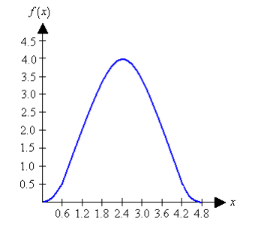

1. What is the value of $f(4.2)$. Round your answer to one decimal place.
2. 0.5
3. 1.7
4. 2.6
5. 3.8
6. What is the smallest value of $x$ for which $f\left(x\right)=2$. Round your answer to one decimal place.
7. 3.6
8. 1.6
9. 0.8
10. 1.2
11. What is the concavity of the graph between $x=1.8$ and $x=2.4$?
12. Concave Up
13. Concave Down
14. What is the concavity of the graph between $x=2.4$ and $x=3.0$?
15. Concave Up
16. Concave Down
17. Where does the graph reach a maximum?
18. 3.5
19. 3.0
20. 2.4
21. 1.8
22. What is the maximum value?
23. 3.7
24. 4.0
25. 2.5
26. 4.5
27. The following is the graph of the function $f\left(x\right).$ Where is the graph increasing?

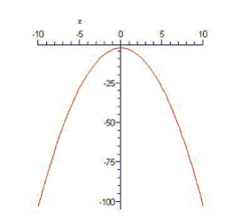

1. From -10 to 0
2. From -1 to 10
3. From -5 to 1
4. From -2 to 10
5. Section 1.3 Exercise 2c
6. 2030
7. 2010
8. 2020
9. 2040
10. Exercise 1.3 14b
11. 1980
12. 1975
13. 1985
14. 1990
15. You sell lemonade for 14 cents per glass. You invested $1.45 in the ingredients. Write an equation that gives the profit *P* = *P*(*n*) as a function of the number of glasses you sell.

a. *P* = 1.45  (1.40)(*n*)

b. *P* = (0.14)(*n*)  1.45

c. *P* = (14)(*n*)  1.45

d. *P* = 0.15  (0.13)(*n*)

1. For a certain function *f* = *f*(*x*), we know that *f* is proportional to *x* and that the constant of proportionality is 20. Find a formula for *f*.

a) *f*(*x*)= 

b) *f*(*x*) = 

c) *f*(*x*) = 

d) *f*(*x*) = 

1. A helicopter takes off from the roof of a building that is 210 feet above the ground. The altitude of the helicopter increases by 140 feet each minute. Use a formula to express the altitude of the helicopter as a function of time.

a. *h*(*m*) = 210 - 140*m*, altitude of the helicopter after *m* seconds, in feet

b. *h*(*m*) = 210 - 140*m*, altitude of the helicopter after *m* minutes, in feet

c. *h*(*m*) = 21 + 140*m*, altitude of the helicopter after *m* minutes, in miles

d. *h*(*m*) = 210 + 140*m*, altitude of the helicopter after *m* minutes, in feet

1. A rental car agency charges $24.60 per day and 8 cents per mile. Use a formula to express the cost of renting a car, in dollars, as a function of the number of days (*d)* you keep it and the number of miles (*m)* you drive.

a. *f*(*d*, *m*) = 24.60*d* + 0.08*m*

b. *f*(*d*, *m*) = 0.08*d* + 24.60*m*

c. *f*(*d*, *m*) = 8*d* + 24.60*m*

d. *f*(*d*, *m*) = 24.60*md* + 8*md*

1. You pay your secretary $7.35 per hour. A stamped envelope costs 54 cents, and paper costs 7 cents per page. How much does it cost to prepare and mail an 8-page letter if your secretary spends 1.60 hours on typing and corrections?

a. $12.38

b. $12.58

c. $17.72

d. $12.86

1. You own a motel and have a pricing structure that encourages rentals of rooms in groups. One room rents for $68, two rooms for $65 each and in general the group rate per room is found by taking $3 off the base of $68 for each extra room. How much money do you charge per room if a group rents 10 rooms?

a. $44

b. $61*9

c. $41

d. $650

1. A rancher wants to use a fence as an enclosure for a rectangular cattle pen with area 754 square feet. Suppose he decides to make one side of the pen 26 feet long. What is the total amount of fence needed?

a. 81 feet

b. 110 feet

c. 61 feet

d. 84 feet

1. The total weight of a rock depends on its size and is proportional to its density. In this context, density is the weight per cubic inch. Let *w* denote the weight of the rock in pounds, *s* the size of the rock in cubic inches, and *d* the density of the rock in pounds per cubic inch. If a 48-cubic-inch rock weighs *w* pounds, write an equation that shows the proportionality relation.

a. *d* = 

b. *d* = 

c. *d* = 

d. *d* = 

1. It is 3,574,000,000 miles from the Pluto to the sun. Light travels 186,000 miles per second. How long does it take light to travel from the sun to the Pluto? Round your answer to the nearest second.

a. 18,960 seconds

b. 19,215 seconds

c. 19,112 seconds

d. 19,319 seconds

19. A rental car agency charges $49.00 per day and 25 cents per mile. Calculate the rental charge if you rent a car for two days and drive 100 miles

1. $225.00
2. $ 123.00
3. $199.00
4. $ 250.00

20. Section 1.4 Exercise 4b

1. 280 minutes
2. 100 minutes
3. 360 minutes
4. 150 minutes