Derivatives

Derivatives Video 1
Popper 09

Definition

Geometric considerations
Average rate of change
The slope connection

Shortcuts to the derivative:
Power Rule
Properties of the Derivative
Scalar Multiplication
Sums and Differences
What does it mean when the derivative is zero?
Increasing and decreasing

Derivatives Video 2
Popper 10

Exponential Functions
More shortcuts:
Product Rule
Quotient Rule

Derivatives Video 3
Popper 11

Application Problems

Appendices

Increasing/Decreasing functions

Definition of Derivative

The Derivative of a function, f (x), is the .
It is denoted

And, while it’s important to know this, it’s also important to know what this means physically in the plane, so let’s back up a bit and talk about rates of change.

If I have a table of inputs and outputs, I can discuss the average rate of change of the outputs in the following way:

The average rate of change from an initial to a final output is the difference in the outputs divided by the difference in the inputs doing the final first in each difference:

AROC:

If y is your output and x is your input this is the slope formula:

Where “final” is defined to be Point 2 and “initial” is defined to be Point 1.

Rates of change and derivatives are intimately connected to the formula for the slope of a line. Watch for how often this comes up in the next few pages.

Here’s a table of values:

inputs (x) | outputs (y)
-3 | 9
-2 | 4
-1 | 1
0 | 0
1 | 1
2 | 4
3 | 9
4 | 16
5 | 25

The average rate of change from −3 (initial) to −1 is

The average rate of change from −1 (initial) to 4 is

Now, I’m using the function as my output generator.

Let’s look at the geometry of these calculations:

From (−3, 9) to (−1, 1), connect these points with a secant line, rather than the line of the graph of the function…

The average rate of change is the slope of the secant line.

that joins these two points:

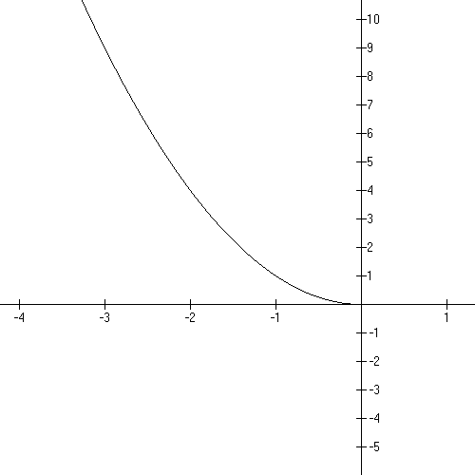

From (−3, 9) to (−1, 1), connect these points with a secant line…this secant line is
really NOT the graphline but it provides two endpoints to the segment that are graph points and a systematic way to get from one to the other in “steps”

From −1 to 4:

The average rate of change from −1 to 4 is

Let’s look at the line joining (−1, 1) and (4, 16)…this is a secant line with slope 3.
If we start at the initial point and step over 1 and up 3 successively…
where do we end up?

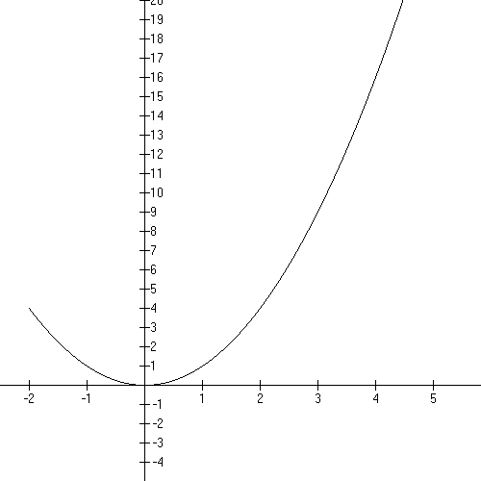

What is the slope of this line?

Note that for each step to the right you go up a specific amount. The first point and second point are graph points, but the points in between on the secant line are not graph points unless your graph is actually a line.

So Average Rate of Change is associated with the slope of the secant line joining two graph points.

Let’s look at one more example.

Given , what is the average rate of change from x = −3 to x = −1?

Sketch this on the graph, then calculate the slope of the secant line joining these points.

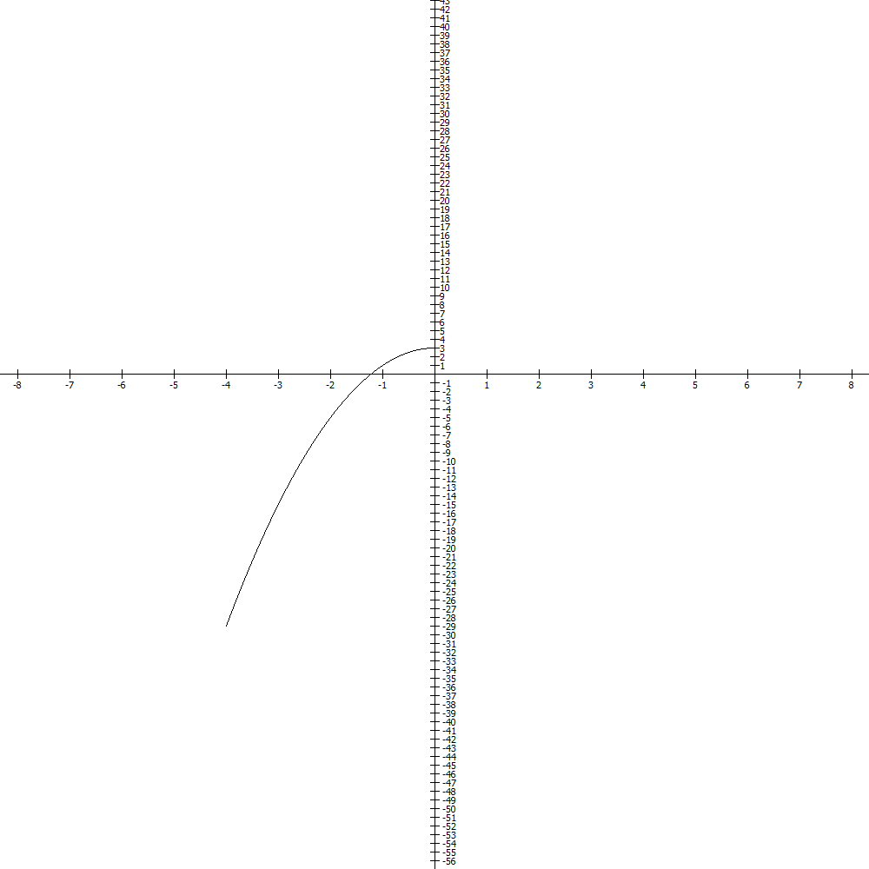
Now let’s put this in words:

The initial graph point is

The final graph point is

For every unit step to the right we go up

This approximates the graph, but NOTE, not exactly what IS the value at −2?
And on the secant line, what is the approximate value?

You can see that you’ll start and end on graph points but your motion doesn’t follow the graph well.
Popper 09, Question 1

Slopes, Difference Quotients, and derivatives are connected.
So let’s start with a given function’s graph and put in and .

Let’s get the set-up from average rate of change through Difference Quotient through derivative using x and x + h as our x’s. Note where “h” is on the x-axis.

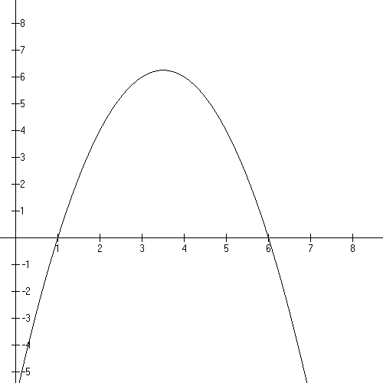

Note that the average rate of change is a stair step like motion from initial to final.

m = Do you see that this is ?

Now let’s actually take the limit as h approaches zero:

What does it mean that “h approaches zero”?

Now let’s look at it at the end of the limiting process. The derivative is the SLOPE of the line tangent at x.

We call the derivative the instantaneous rate of change of y with respect to x.
It is the slope of the tangent line at x. Amazingly, it’s a one-point slope.

Now let’s work with this a bit.

Given .

Find
which is the instantaneous rate of change of x with respect to y at x = 2.

First let’s find .
Find the DQ
Take the limit of the DQ
Evaluate the solution at x = 2.

Difference Quotient:

Evaluate it

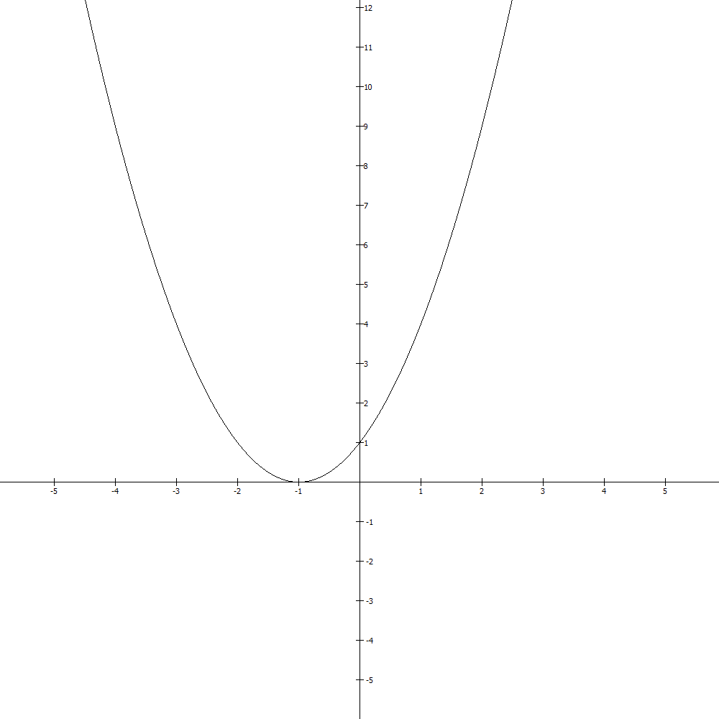

Now let’s put some words to it:

The rate of change of x with respect to y at x = 2 is the expected change in y for an infinitesimal movement rightward from 2.

If the derivative is 3, that’s a small positive change. If it’s 110, that’s a large positive change. In both of these cases, the graph is increasing.

If the derivative is −0.3, that’s a small negative change. If it’s −57, that’s a good sized negative change. In both of these cases, the graph is decreasing.

Popper 09, Question 2

Shortcuts to getting the derivative:

First let’s do it the LONG way. Then we’ll look at pictures and a shortcut.

Given Find its derivative.

We will follow these steps.

- Find the DQ
- Take the limit of the DQ as

Finding the Difference Quotient:

Subtracting f(x) gives:

Dividing by h gives: for the Difference Quotient

Last:

Taking the limit as h approaches zero gives: which is the derivative.

Now let’s look at what this tells us:

In the plane:

If x = 1, then f (1) = 1 and the slope of the line tangent to this graph at x = 1 is 3.
You evaluate the derivative at the x value to get this number, and it will change as x changes.

In the “Big Picture”:

For an itsy bitsy step off of 1 to the right, the y value will go up 3 times the size of that step. That is to say, the instantaneous rate of change of y with respect to x is 3.

This means that the measure of the change in the graph for places close to one is 3…for every horizontal step horizontally you take 3 times that amount vertically.

In fact, given this point (1, 1) and m = 3, I can come up with the FORMULA for this tangent line using the old point slope formula:

y − 1 = 3 (x − 1) i.e. y = 3x − 2.
This is nice to know and a standard question.

Here’s a picture of that line on the graph with the tangent line on it at x = 1.
3 is the instantaneous rate of change of x with respect to y for this function at x = 1.

Note that the rate of change is NOT a constant. It changes depending on where you are on the graph.

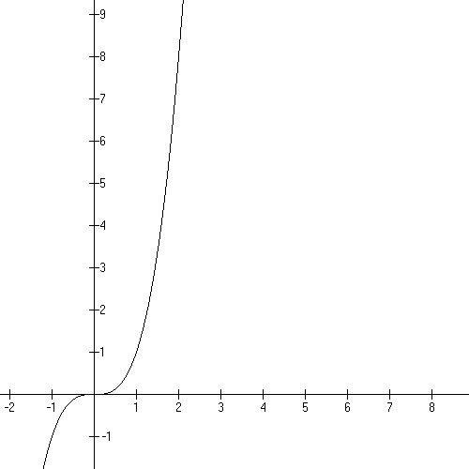

Popper 09, Question 3

Now let’s begin seeing the derivative as a function related to our original function that calculates instantaneous rates of change for the original function.

It works like this:

The original function takes x and computes the second coordinate for the graph point at x.
The derivative takes x and computes the instantaneous rate of change of the function at x.

Let’s look at a table of these:

x | Graph point | Slope of tngt l
−2 | −8 | 12
−1 | −1 | 3
0 | 0 | 0
3 | 27 | 27

Let’s talk about lines with slopes like the following:

m < 0

m = 0

m > 0 m >> 0

For a tiny step horizontally the vertical motion is approximately multiple of the slope.
Notice that the formula for the derivative above guarantees a positive slope over the course of the function. This is important and it means that the graph is increasing on it’s domain.
And now, a tiny summary:

Average rate of change: slope of the secant line

Instantaneous rate of change: slope of the tangent line

For derivatives:

If the slope is negative, the graph is decreasing.
If the slope is positive, the graph is increasing.
If the slope is zero, there is a turn around point at that x.

Shortcut #1 The Power Rule!

Given:

Example 1 again

Let’s track n and n – 1 in this

Example 2

$$f(x)=x^{\text{27}}$$

Example 2A:

Example 3

f(x) = 5

This will be a big deal in the next module on Integration!

Popper 09, Question 4

To review:

Domain

End Behavior

Range

y-intercept

x-intercept

DERIVATIVE!

Properties of derivatives:

Scalar Multiplication: Given a multiple of a function, the derivative has the same multiplier.

Example 4: $f(x)=5x^{4}$ numbers like 5 are called “scalars”.

Don’t forget
“+ c”

$$f(x)=−\frac{1}{3}x^{6}$$

Popper 09, Question 5

Sums and Differences: The derivative of a sum or a difference is the sum or difference of the derivatives of the summands (terms).

Example 5: $f(x)=3x^{2}+2x−3$

Example 6: $f(x)=\frac{3}{x^{2}}+2x−1=3x^{−2}+2x−1$

Popper 09, Question 6

Example 7:

Find the equation of the tangent line at x = 3 for $f(x)=x^{3}+x^{2}−5$.

$f'(x)=3x^{2}+2x$ $f'(3)=\text{33}$= m

f(3) = 27 + 9 −5 = 31. This is the point to use: (3, 31) in the point slope equation:

$y−y_{0}+m(x−x_{0})$ gives y − 31 = 33(x − 3)

The tangent line is y = 33x − 68.

Sketch it on the graph provided.

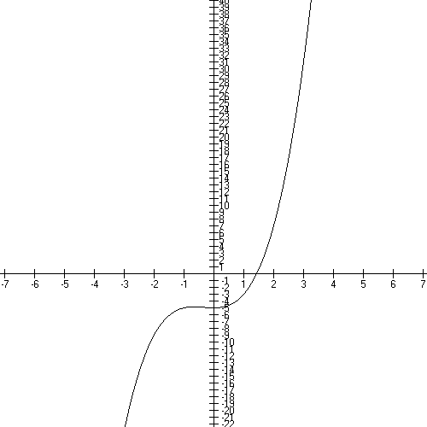

Now let’s talk about the typical polynomial question:

Given this polynomial, find:
Domain, range, intercepts, derivative, sketch, equation of tangent line at a given point.

Example 8: Given: $f(x)=x^{2}−6x+5$

Domain: all Real Numbers
Vertex: CTS: y = $(x−3)^{2}−4$…. (3, −4)
x-intercepts: (1, 0) and (5, 0)
y-intercept: (0, 5)

Derivative: $f'(x)=2x−6$
Equation of tangent line at 2 and at 3 and at 5.

$f'(2)=−2$ f(2) = −3 y + 3 = −2(x −2)…y = −2x + 1 m < 0
$f^{'}(3)=0$ f(3) = −4 y + 4 = 0(x − 3)….y = − 4 m = 0
$f'(5)=4$ f(5) = 0 y + 0 = 4(x − 5)….y = 4x − 20 m > 0

Sketch them on the graph:

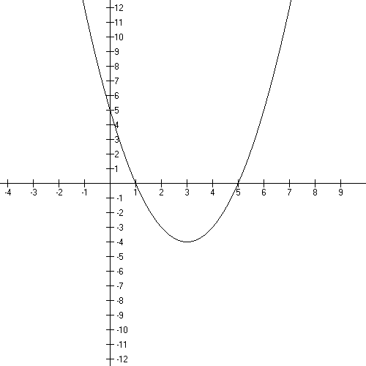

Popper 09, Question 7

What does it mean when the derivative is zero?

It means that the instantaneous rate of change is going from a negative number to a positive number (or vice versa) and that you’ve found a turn-around point.

What does it mean when the derivative is positive?

The graph is increasing.

What does it mean when the derivative is negative?

The graph is decreasing.

Increasing and decreasing functions:

A function is increasing if .
A function is decreasing if .

Let’s look at

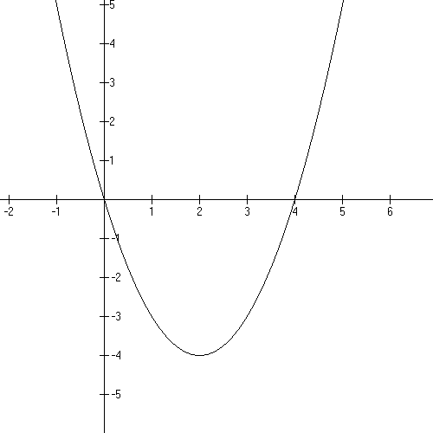
Where is this graph increasing or decreasing?

Where is the turn around point?

Let’s put on some tangent lines in a few places…

Think of replacing the actual curve with a short section of a line…does the line have positive or negative slope if the graph is increasing? decreasing?

Let’s look at some slopes of the lines tangent to our parabola:

(x, f(x))
(−1, 5) | −6 | negative
(0, 0) | −4 | x-intercept, negative
(1, −3) | −2 | negative
(2, −4) | 0 | VERTEX - zero
(3, −3) | 2 | positive
(4, 0) | 4 | x-intercept, positive
(5, 5) | 6 | positive

The graph is decreasing to the left of the vertex and the slopes of the tangent lines are negative. The graph is increasing to the right of the vertex and the slopes of the tangent lines are positive. At the turn around point, the vertex, the slope of the tangent line is zero.

Popper 09, Question 8

How do you find turn around points?

Set the derivative = 0 and solve for x.
Then use that x in the original formula to get the y value of the graph point.

Example 9:

Domain: All Real numbers
Range: All Real numbers
x-intercepts: −3, 3, 13
y-intercepts: −117
End behavior:
It’s continuous everywhere because it’s a polynomial.

Derivative:

Where is the graph increasing and decreasing? We have TA1 and TA2

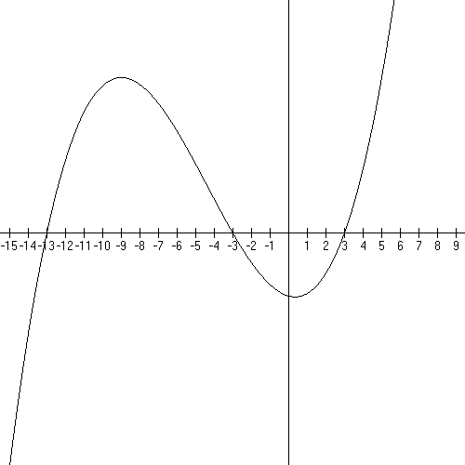

Where are the TAPs? Set the derivative equal to zero and solve for x!

= 0

[at the TAPs the slope of the tangent line = 0]

x = 1/3 and x = − 9

What are the graph points?

f(1/3) = =

f(−9) =

Now let’s talk about where the graph is increasing or decreasing with the appropriate x’s in the intervals. And let’s talk about the range, too!

So now the typical polynomial question looks like this:

Given this polynomial: Domain, range, intercepts, derivative, sketch, equation of tangent line at a given point, location of turn-around points, where is it increasing/decreasing, where is it continuous ?

Popper 09, Question 9

Let’s look at another polynomial

Example 10:

We’ll call the x-intercepts x1, x2, and x3; they’re actually irrational numbers.

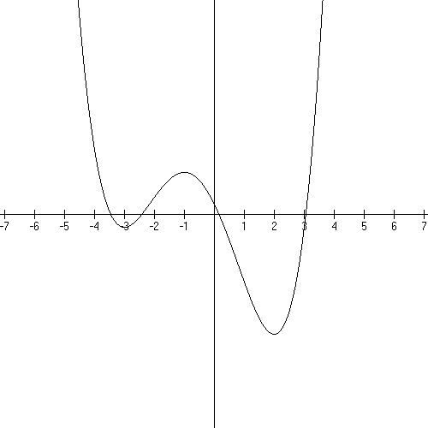

Let’s mark the graph for increasing/decreasing and find where the turn-around points are.
Note that the RANGE depends of the y associated with the turnaround point on the rightmost…it’s [f(TA3) , ). If I knew the x value at the turnaround point, I could calculate the associated y value and tell you exactly what the range is…

Take the derivative of f(x) and set it equal to zero:

Note that there’s a common factor of twelve, divide it out:

Use the Rational Root theorem and synthetic division to find that the factors of the derivative are

12(x + 3)(x − 2)(x + 1)

So the turn around points are at x = −3, x = 2, and x = −1.

Evaluate the original function to get the actual graph point y’s for each x.

and f (2) will give you what you need to state the range…
Popper 09, Question 10

End Video 1

Now not everything is a polynomial. For example, we have

Exponential Functions.

Let’s look at two of these:

the exponential function base e and the exponential function base 10.

Example 11

Domain: all Real Numbers

Range:

x-intercepts: none

y-intercept: (0, 1)

The actual value of e is 2.7183…. and it’s irrational. I generally characterize it as “3-ish”

The graph is leftward asymptotic to y = 0, aka the x axis.
On the right it goes off rather quickly to positive infinity.

Let’s talk turnaround points: NONE

This graph is increasing everywhere!

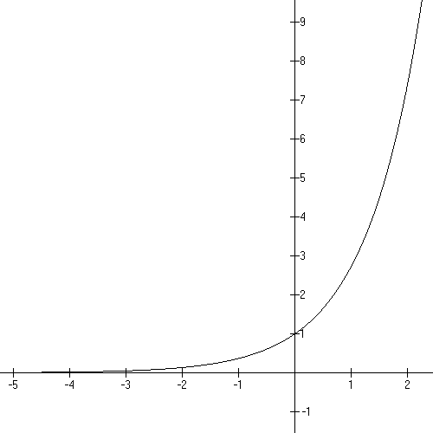

Let’s talk slope of the tangent lines.

The Difference Quotient:

Since $e^{x}$isn’t affected by the limit, I’ll work with the factor that has an “h” in it:

Now let’s take the limit as h approaches zero:

Notice that there is not any nice “disappearing h” action. We actually MUST do a table!

h = .01 | h = .001 | h = .0001
1.005017 | 1.0005001 | 1.0000500002
h = −.01 | h = −.001 | h = −.0001
.99501 | .99950 | .999950002

So the .

This function is it’s own derivative! That is amazing and very NOT “polynomialish”!
This astonishing fact is true and makes it one of the most interesting functions in the world.

Now let’s talk about slopes and formulas for the tangent lines.

At x = 1

So the formula for the tangent line using the point (1, e) and the slope, m = e gives us:

y − e = e(x − 1) y = ex.

At x = 2

note that at 2 the instantaneous rate of change is 9ish times 2.

Let’s sketch these onto the graph:

Example 12
So now let’s look at .

The domain is all Real numbers and the range is . The graph is leftward asymptotic to zero and rightward up quickly to positive infinity. There are no x-intercepts and the y-intercept is (0, 1). The graph is everywhere increasing and has no turnaround points.

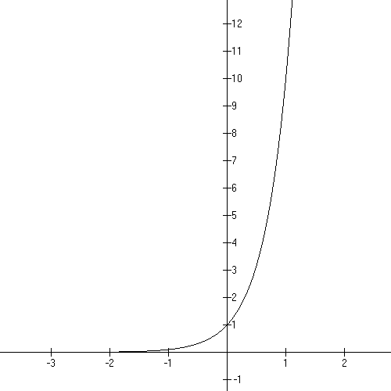

These graphs look a lot alike, BUT if you look closely you’ll see that the first graph has the graph point (1, 3ish) and this one has (1, 10). It gets large faster.

Now for the Difference Quotient:

. Note that ${\text{10}}^{x}$ isn’t affected by the limit

so let’s look at and let’s note that

h = .01 | h = .001 | h = .0001 | h = .00001 | h = .000001
2.32929… | 2.305238… | 2.302850…
h = −.01 | h = −.001 | h = − .0001 | h = − .00001 | h = − .000001
2.276277… | 2.299936… | 2.30232…

So, we find that the multiplier is a value called ln(10) (pronounced: “ natural log of 10”)

What is the instantaneous rate of change for at x = 2?
Well the derivative of the graph is approximately$2\text{.}\text{30}({\text{10}}^{2})=\text{230}$.
For one tiny step sideways at 2 the y value goes up 230. That’s pretty steep, folks.

This is a pattern for the exponential functions:

Only escapes that multiplier because ! So the derivative of an exponential is a specific, dependable multiple of itself!

Popper 10, Question 1

And there are functions that come from multiplying and
dividing other functions:

Now let’s look at the effect of multiplying unlike functions with one another and we’ll look at the instantaneous rate of change at various points along these graphs.

Example 13

The domain is Why is that? rules!

Here’s the graph. Note that the range is from the turn-around point to positive infinity.

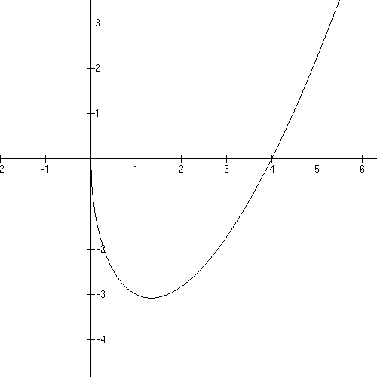

We have two ways to get the derivative:

One way is to multiply the functions and use the Sum rule.
The other way is to use the Product Rule.

Let’s do it both ways.

Multiply and use the Sum Rule

The derivative is, then,

$\frac{3}{2}x^{\frac{1}{2}}−2x^{−\frac{1}{2}}$ Here’s some room for the steps:

Now let’s solve $\frac{3}{2}x^{\frac{1}{2}}−2x^{−\frac{1}{2}}=0$

multiply both sides by the square root of x

Popper 10, Question 2

More shortcuts: Product Rule!

If f(x) is a string of factors, you may use the Product Rule. For the simplest case,
suppose f(x) = h(x)(p(x)).

$f'(x)=h'(x)⋅p(x)+h(x)⋅p'(x)$

Example 13, cont.:

here: $h(x)=\sqrt{x} p(x)=x−4$

We know: $h'(x)=\frac{1}{2\sqrt{x}}$ and p’(x) = 1

So the derivative is:
$$\begin{aligned}\frac{1}{2\sqrt{x}}(x−4)+\sqrt{x} (1)= \\ \\ \frac{x−4}{2\sqrt{x}}+\sqrt{x}= \\ \\ \frac{1}{2}\sqrt{x}−\frac{2}{\sqrt{x}}+\sqrt{x} \\ \\ \\ \frac{3}{2}\sqrt{x}−\frac{2}{\sqrt{x}}=\frac{3}{2}x^{\frac{1}{2}}−2x^{−\frac{1}{2}}\end{aligned}$$

Mnemonic: If f(x) = First function times Second Function = F(S)

$f'(x)=F'S+\text{FS}'$

Example 14:

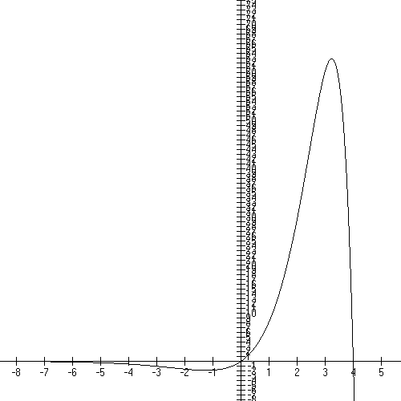

Domain: all Real numbers
Leftward asymptotic to x = 0.
x-intercepts: 0 and 4

Where are the turn-around points?

f(x) = E(Q) the derivative is E’(Q) + E(Q’)

recall that the derivative of is .

Now the first factor is NEVER zero so
Using the quadratic formula on the second factor we find that

Which is pretty reasonable if you look at the graph…most everybody can see that it’s around −1 and 3 that there are turn arounds.

Let’s check for the y values:

The turn around on the right is (3.23, 63)ish.

The turn around on the left is (−1.23, −1.8)ish.

Write down the increasing and decreasing information in interval notation for this graph:

Increasing:

Decreasing:

Popper 10, Question 3

Now for the Quotient Rule:

recall that quotient is what you get when you divide…so we’re talking about rational functions here.

The Quotient Rule for

QR says: .

Please know this by heart.

Example 15

Domain: all Reals except 2
Range: all Reals except 1

x-intercept (−6, 0)
y-intercept (0, −3)
VA x = 2 discontinuous here, limits to infinity vertically
HA y = 1 limits to here, horizontally as

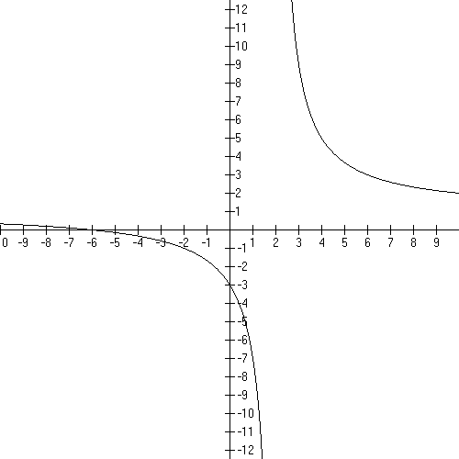

Where is
the graph
increasing
and
decreasing?

So, let’s talk tangent lines to the curve? Are there tangent lines to the curve at x = 5 or at x = −1. You bet and, more, each tangent line has a slope…the derivative at that number for x.

So, using the quotient rule, we can calculate the derivative:

The top polynomial is (x + 6) and it’s derivative is 1.
The bottom polynomial is (x − 2) and it’s derivative is 1.

Now, at x = 5, the graph point is ( 5, 11/3) and the slope of the tangent line is
−8/9.

The equation of the tangent line is

y − 11/3 = −8/9(x − 5).

At x = −1, the graph point is (−1, −5/3) and the slope of the tangent line is
−8/9. Amazing but true.

However, the equation
of the tangent line is different:

y + 5/3 = −8/9(x + 1).

So they are parallel at these
two points!

Example 16

Domain: all Reals except 3
Range: all Reals except 2

x-intercept (−3, 0)
y-intercept (0, −2)

VA x = 3, discontinuous here, goes off to vertically
HA y = 2, limits to here, horizontally as

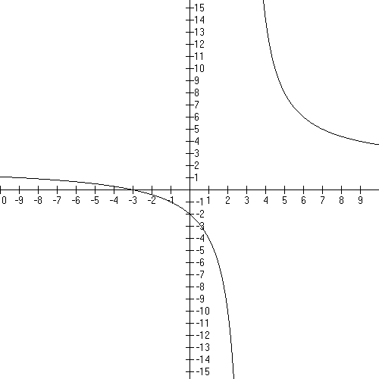

Where is this graph increasing and decreasing?

Let’s look at getting the derivative:

The top polynomial is 2x + 6 and it’s derivative is 2.
The bottom polynomial is x − 3 and it’s derivative is 1.

So, for example at x = 3 there is NO VALUE for the derivative…the graph is undefined at that place so there’s not a tangent to the not-graph. The graph is discontinuous there, too, remember?

BUT, at x = 1, the slope of the tangent line is −12/4 = −3. The graph point is (1, −4).
And the equation of the tangent line is

y + 4 = −3(x −1).

Popper 10, Question 4

Summarizing:

The derivative is a calculated quantity that tells you the slope of the tangent line to any point on the graph. The definition of a derivative is taking a limit as h approaches zero, but we’ll use the shortcuts to find them. This is the instantaneous rate of change of the graph at a chosen point.

For a polynomial, the domain is all Real numbers and the function is continuous everywhere.

An example of the sum/difference rule:

factor by grouping!

The end behavior is .
The x-intercept are at −4 and the y-intercept is at 16.

The derivative:
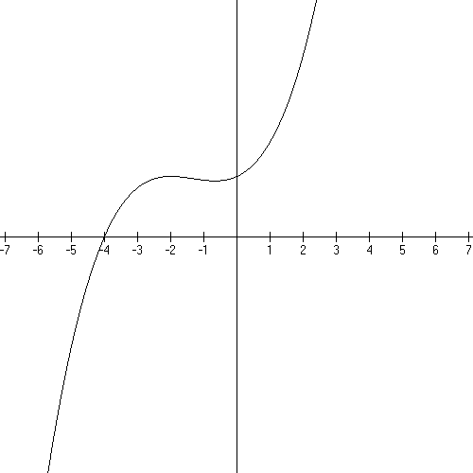

Where are the turn around points?

−2 and −2/3

Where is the graph increasing and decreasing?

Increasing (

Decreasing (−2, −2/3)

Popper 10, Question 5

An example of the product rule:

Why is the domain all Real numbers?
How does this show that there’s no vertical asymptote? You might be tempted to say there’s a VA a x = 4 but since you KNOW the domain, you can tell….

Leftward asymptotic to y = 0, though.
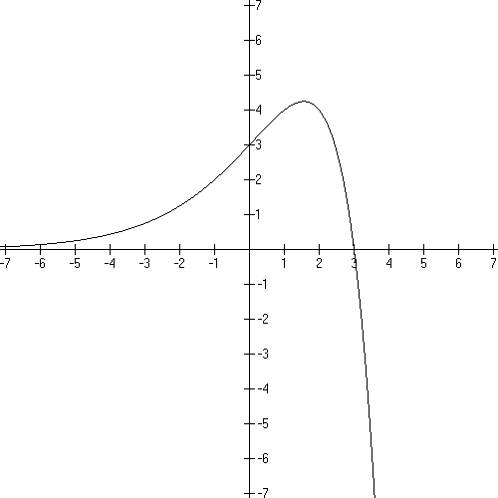

.

Since the exponential function is NEVER zero, we can solve the linear part for zero giving us x

Where is the graph increasing and decreasing?

Increasing:

Decreasing:

This means that the slopes of the tangent lines are positive to the left of 1.55, zero at 1.55, and negative to the right of it.

Popper 10, Question 6

An example of quotient rule:

Domain: all Real numbers except zero
Range: all Real numbers except zero

no intercepts

VA x = 0, discontinuous here
HA y = 0
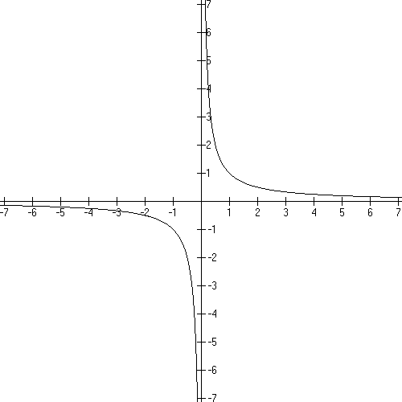

The top polynomial is 1; it’s derivative is zero.
The bottom polynomial is x; it’s derivative is 1.

Which is always negative and never zero.
And it’s true, this graph is decreasing on it’s domain.

Note that there is NO tangent line at x = 0 because the function is not defined there.

Popper 10, Question 7

Popper 10, Questions 8

Popper 10, Question 9

Popper 10, Question 10

End of Video 2

Application problems!

Always important!

*
The revenue in dollars from the sale of x car seats for infants is given by

A. Graph the revenue curve over its domain.

B. Find the revenue for a production level of 1,000 car seats.

C. Find the average rate of change in revenue from 500 to 1,000 car seats.
Write a brief verbal interpretation of the results.

D. Find the instantaneous rate of change at 1,000 car seats.
Write a brief verbal interpretation of the results.

For the graph:
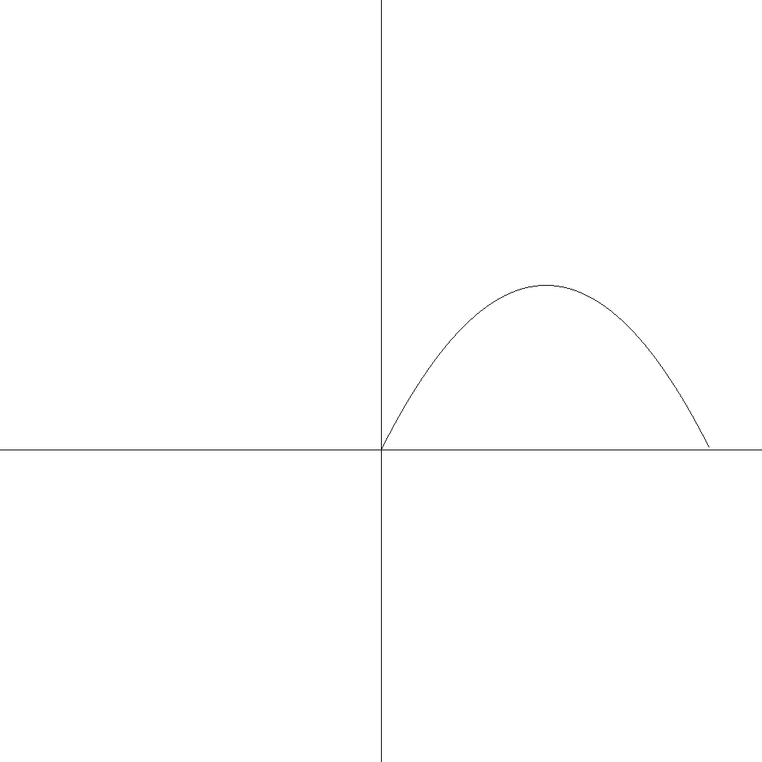

AROC from 500 to 1000:

The slope of the secant line joining these two graph points in 22.5.

This means that you are getting, on average, $22.5 per baby seat when production changes from 500 seats to 1000 seats

IROC at 1000

The derivative is

The slope of the tangent line at x = 1,000 is 10. This is a fairly large positive number and means that the revenue from the 1001st car seat will be $10 for that unit. Note that the AVERAGE revenue is $22.5, but the actual income from the 1000th unit is $10. So revenue is slowing down as we approach the vertex.

Note that at 1200 units, the slope of the tangent line is zero. And for 1400 units the slope of the tangent line is −10 which means revenue, while still positive, is decreasing with each unit sold.

Right at the vertex is where we want to have a sale, or change our production methods or do something before revenue goes negative at 2401 units.

Popper 11, Question 1

*
The annual US production of talc, a soft mineral, in thousands of metric tons, is given by

where t is time in years and t = 0 corresponds to 1997.

A. Graph this function from 1997 to 2007.

B. Find the annual production in 2000.

C. Find the average rate of change in production from 1998 to 2002.
Write a brief verbal interpretation of the results.

D. Find the instantaneous rate of change of production in 2002.
Write a brief verbal description of the results.

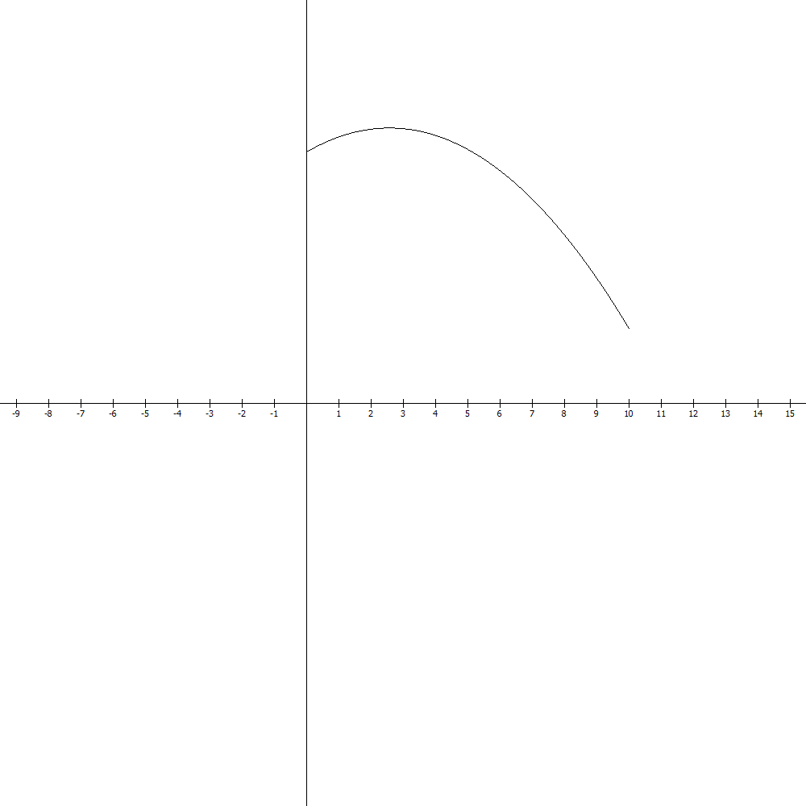

To graph this up to 2007, not that it’s 10 years from 1997 to 2007. We will use the interval [0,10] as our domain.

Here are our starting and ending points.

Where is the peak production?

.57 of a year is about the 30th week. So the peak production is 30 weeks into 1999.

Production increased til then and has decreased since.

AROC 1998 to 2002 1998 is zero, 2002 is 5

This is the slope of the secant line joining the two graph points. Note that the slope is still positive because we haven’t gotten enough into the decline! In fact, if a manager is not careful, she might think that things are ok because the average revenue per thousand metric ton is positive.

IROC 2002

While the derivative is a large negative number. Note that REVENUE is still positive but it is decreasing with each additional thousand metric tons. The revenue for the next week will be 730 LESS than the preceeding week.

And in which year will the revenue zero out?

Use the quadratic formula!

[ There’s a negative x as well, but we’ll ignore that one – that’s over on the left of zero!]

In the first 3 months of 2008!

They need to “do something” before then!

Popper 11, Question 2

Popper 11, Question 3

*
The number of female newborn deaths per 100,000 births in France is given by

Where t is in years and t = 0 corresponds to 1980.

A. Graph this function from 1980 to 2005.

B. Find the number of newborn girls who died in 2001.

C. Find the instantaneous rate of change of mortality in 1996.
Write a brief verbal interpretation of the results.

From 1980 to 2005 is 25 years so our domain is [0, 25].
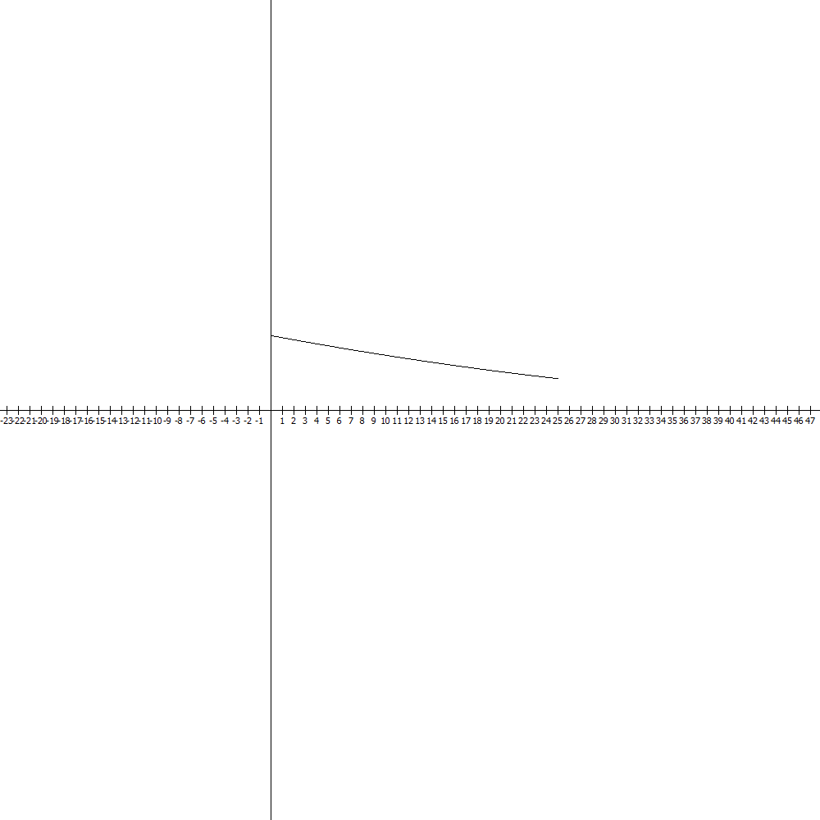

So France halved
the mortality rate for female newborns in 25 years.

In 2001 approximately 11 baby girls per 100,000 births died. 11/100,000 is .00011 which is .01%.

The instantaneous rate of change in mortality per 100,000 births in 1996 is

We would really talk about 49% of a baby girl, we’d note that the rate is decreasing.

Popper 11, Question 4

*
The total sales of a company in millions of dollars t months from this month is given by

Find the sales a year from now and find the derivative at that time and interpret these results.
Use the results to predict the sales in 13 months.

A year from now is t = 12 months.

million

The prediction will use the derivative.

0.144(1,000,000) = 144,000

We’ll earn about $144,000 dollars more than this month.

Let’s check this:

million

7.60 – 7.46 = .14 million which is 144,000 dollars.

Popper 11, Question 5

*

If $100 is invest in an account that earns 6% compounded annually, then the amount in the account after t years is given by

Find the amount after 5 years and the instaneous rate of change at that time.

use your key to do this.
mine is a “second fcn”

This says that the rate of change of the amount with respect to a year will be about $7.80.

Let’s check this:

So, not quite perfect, but only 23 cents off!

You can use derivatives to predict what will happen in the next unit…the cost of the next unit to produce, the revenue from the next unit, the income from the next unit. This can be very handy.

Popper 11, Question 6

*

Suppose a person learns y items in x hours as given by

Graph the learning curve and give the rate of learning at 1 hour and at 6 hours.

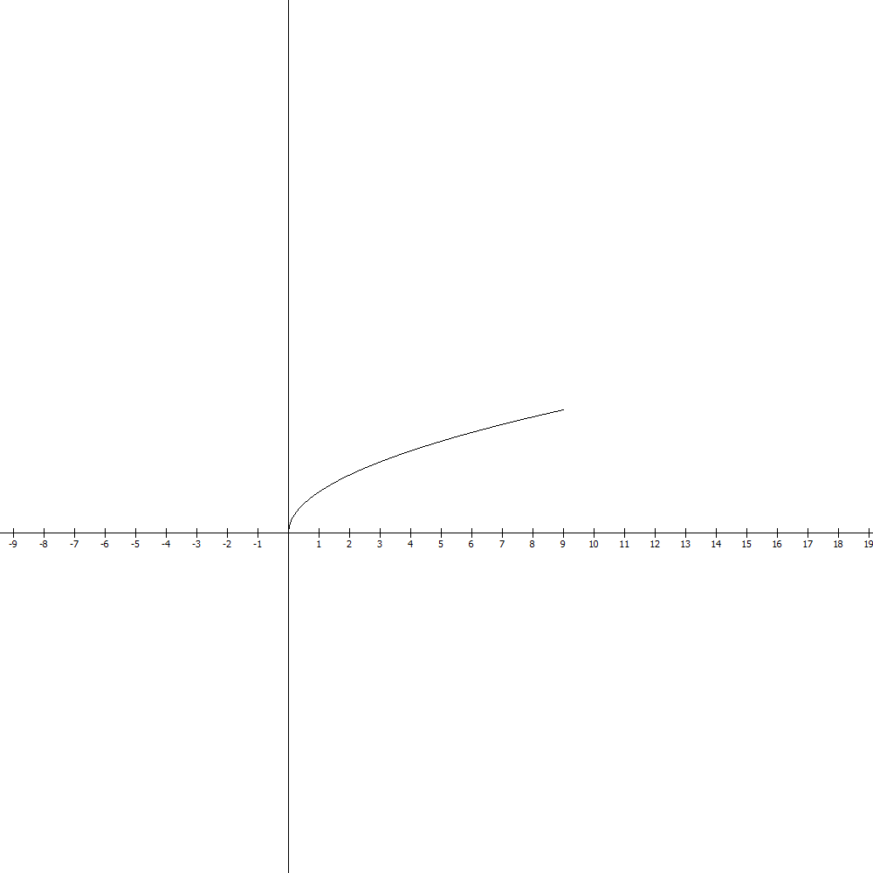

So starting out the student knows none of the items but after 9 hours the student knows 150 items.

This says that the rate of learning items at 1 hour is 50 items and at 6 hours it’s still positive but it’s slowed down to about 20 items in the 6th hour.

Popper 11, Question 7

*

Suppose that in a given gourmet food shop people are willing to buy x pounds of chocolate candy per day at $p per quarter pound, as given by the following equation:

What is the instantaneous rate of change of demand with respect to price when the price is 5 dollars per quarter pound?

When the price is $5

The rate of change is negative so as price goes up demand goes down. The demand is decreasing at a rate of 7 quarter pounds per dollar.

Popper 11, Question 8

*

The total sales in thousands of CDs for a compact disk are given by

Find the derivative using the quotient rule.

Find the sales and the rate of change of the sales at t = 10

Use the results to estimate the number of sales at t = 11

This says that after 10 months sales are 60,000 and the rate of change is 4,000 at 10 months. The estimated sales at 11 months will be 64,000.

Popper 11, Question 9

Popper 11, Question 10

