In class assignment – Topic 1 – Geodesic on a cube

Name:

From Wikipedia, we find:

In mathematics, a geodesic /ˌdʒiəˈdɛsɪk, -ˈdisɪk/[jee-uh-des-ik, -dee-sik] is a generalization of the notion of a "straight line" to "curved spaces". In presence of a metric, geodesics are defined to be (locally) the shortest path between points on the space.
The term "geodesic" comes from geodesy, the science of measuring the size and shape of Earth; in the original sense, a geodesic was the shortest route between two points on the Earth's surface, namely, a segment of a great circle. The term has been generalized to include measurements in much more general mathematical spaces; for example, in graph theory, one might consider a geodesic between two vertices/nodes of a graph.
Geodesics are of particular importance in general relativity, as they describe the motion of inertial test particles.

Exploration: A Common Cube Conundrum
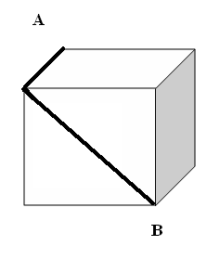
Suppose one desired to move along the surface of the cube from the top far corner (point A) to the near bottom corner (point B). Would the dark line path marked in the picture be the shortest route from point A to point B?

A1. If you agree, justify your answer; use the new vocabulary in your answer.

A2. If you do not agree, describe the geodesic and justify your answer in a mathematical way. Compare the suggested geodesic with your path length and argue mathematically which is the shorter route.

In either case, find both the exact answer using algebra and an approximation from your calculator.

How would you demonstrate the answer using graph paper for the faces of the cube?
Sometimes a “low-tech” approach is very convincing! (graph paper is attached).

Can you build a cube using origami and test out what you think with strips of paper?

B. How would you teach that the exact answer, the graph paper approach, and the approximation are the “same”?

Answers:

A: The shortest route is:

B: Some ideas for teaching this are:

