Circle Map and Frame
- It is important to see a connection between what we do every day and what we will experience in the future. Please use this circle map to help frame the work we do here in class with what you have planned for your future.
- Inner Circle: Let the inner circle represent your math class.
- How is what we do here every day connected to your immediate goals? Think about your immediate goals: grades, understanding, study skills, math class next year, etc. Write about these things in the next circle, the one closest to the inner circle.
- Inside the Frame: Extend the connections you have written down. What are your future goals? Think about how what we do every day in math class is related to these goals and write down those thoughts inside the frame.
- Outside the Frame: Do you have long term goals? What are they? Feel free to write about these goals outside the frame.
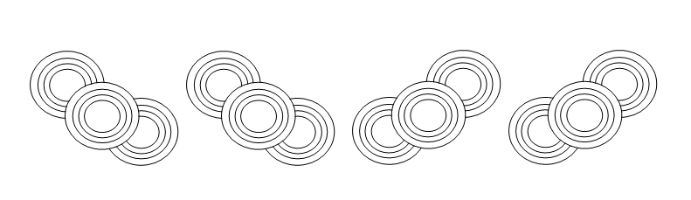

Circle Map and Frame | Name: ____________________

